## +Introduction

This exercise requires you to know the following aspects of SQL:

|  |  |
| --- | --- |
| CREATE TABLE | Concatenation |
| SQL Data Types | Formatting dates and numbers |
| INSERT INTO | Column aliases |
| SELECT | Simple JOIN statements |
| WHERE clause | Complex JOIN statements |
| LIKE and wildcards | Subquery |

## Exercise 1 – Northwind Queries (40 marks: 5 for each question)

* 1. Write a query that lists all Customers in either Paris or London. Include Customer ID, Company Name and all address fields.

SELECT CustomerID, CompanyName, Address, City, Region, PostalCode, Country FROM Customers WHERE City ='Paris' OR City = 'London';

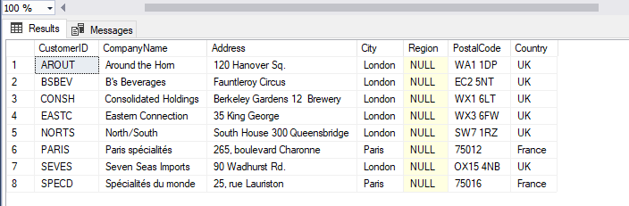

* 1. List all products stored in bottles.

SELECT * FROM Products WHERE QuantityPerUnit LIKE '%bottles';

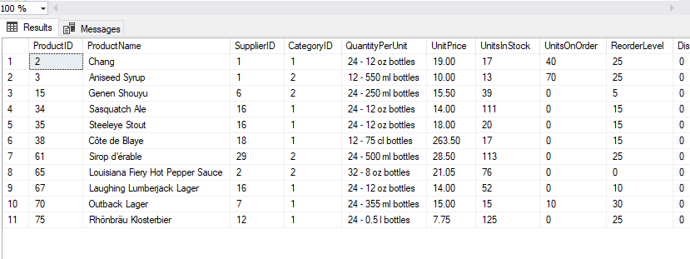

* 1. Repeat question above, but add in the Supplier Name and Country.

|  |
| --- |
| SELECT Suppliers.CompanyName, Suppliers.Country, Products.* |
|  | FROM Products |
|  | INNER JOIN Suppliers ON Products.SupplierID = Suppliers.SupplierID |
|  | WHERE QuantityPerUnit LIKE '%bottles'; |

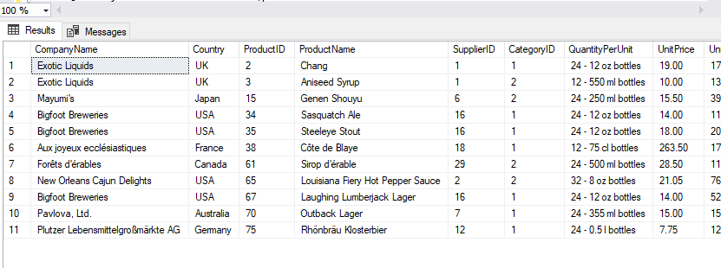

* 1. Write an SQL Statement that shows how many products there are in each category. Include Category Name in result set and list the highest number first.

|  |
| --- |
| SELECT COUNT(Categories.CategoryID) 'CategoryID', Categories.CategoryName FROM Categories |
|  | INNER JOIN Products ON Categories.CategoryID=Products.CategoryID |
|  | GROUP BY Categories.CategoryName |
|  | ORDER BY COUNT(Categories.CategoryID) DESC; |

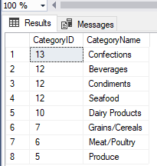

* 1. List all UK employees using concatenation to join their title of courtesy, first name and last name together. Also include their city of residence.

SELECT CONCAT(TitleOfCourtesy, ' ', FirstName, ' ', LastName) AS 'Full Name & Title', City FROM Employees;

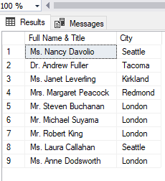

* 1. List Sales Totals for all Sales Regions (via the Territories table using 4 joins) with a Sales Total greater than 1,000,000. Use rounding or FORMAT to present the numbers.
  2. Count how many Orders have a Freight amount greater than 100.00 and either USA or UK as Ship Country.

SELECT COUNT(OrderID) FROM Orders WHERE Freight > 100.00 AND ShipCountry IN ('USA', 'UK');

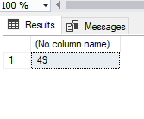

* 1. Write an SQL Statement to identify the Order Number of the Order with the highest amount of discount applied to that order.

SELECT OrderID, Discount FROM [Order Details] WHERE Discount = (SELECT MAX(Discount) FROM [Order Details]);

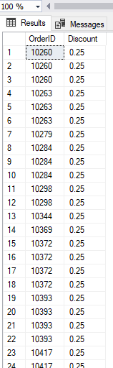

## Exercise 2 – Create Spartans Table (20 marks – 10 each)

2.1 Write the correct SQL statement to create the following table:

Spartans Table – include details about all the Spartans on this course. Separate Title, First Name and Last Name into separate columns, and include University attended, course taken and mark achieved. Add any other columns you feel would be appropriate.

IMPORTANT NOTE: For data protection reasons do NOT include date of birth in this exercise.

DROP TABLE spartansTable;

CREATE TABLE [spartansTable](

[spartanID] [int] IDENTITY(1,1) NOT NULL,

[title] [char](6) NULL,

[firstName] [varchar](255) NULL,

[lastName] [varchar](255) NULL,

[universityAttended] [varchar](255) NULL,

[courseTaken] [varchar](255) NULL,

[gradeAchieved] [varchar](6) NULL)

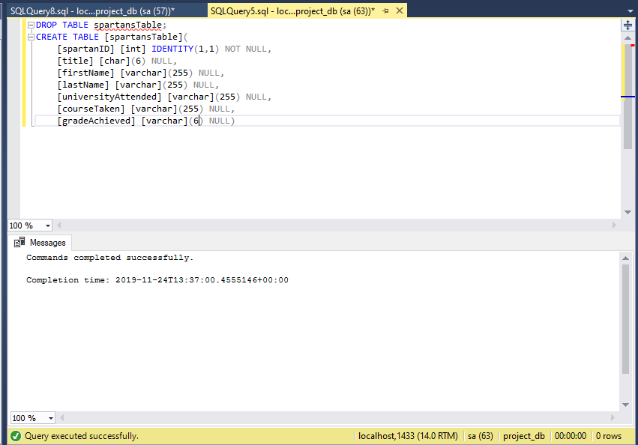s

2.2 Write SQL statements to add the details of the Spartans in your course to the table you have created.

INSERT INTO spartansTable

(title, firstName, lastName,universityAttended, courseTaken, gradeAchieved)

VALUES

('MR', 'Joyel', 'Shaju', 'Coventry', 'Computer Science', '1st');

INSERT INTO spartansTable

(title, firstName, lastName,universityAttended, courseTaken, gradeAchieved)

VALUES

('MR', 'Victor', 'Granados', 'Granada', 'Information and Documentation', '2nd');

INSERT INTO spartansTable

(title, firstName, lastName,universityAttended, courseTaken, gradeAchieved)

VALUES

('MR', 'Jack', 'Farmer', 'Leeds', 'Physics', '2:1');

INSERT INTO spartansTable

(title, firstName, lastName,universityAttended, courseTaken, gradeAchieved)

VALUES

('MR', 'Mohammad', 'Khwaja', 'Westminster', 'Electronic Engineering', '2:2');

INSERT INTO spartansTable

(title, firstName, lastName,universityAttended, courseTaken, gradeAchieved)

VALUES

('MR', 'Thomas', 'Briggs', 'Bournemouth', 'Exercise Science', '1st');

INSERT INTO spartansTable

(title, firstName, lastName,universityAttended, courseTaken, gradeAchieved)

VALUES

('MR', 'Shaqi', 'Abdullah', 'Brunel', 'Mechanical Engineering', '2:1');

INSERT INTO spartansTable

(title, firstName, lastName,universityAttended, courseTaken, gradeAchieved)

VALUES

('MR', 'Zaid', 'Iqbal', 'QMUL', 'Computer Science', '2:1');

INSERT INTO spartansTable

(title, firstName, lastName,universityAttended, courseTaken, gradeAchieved)

VALUES

('MR', 'Paul', 'Brewer', 'Hull', 'Computer Science', '1st');

INSERT INTO spartansTable

(title, firstName, lastName,universityAttended, courseTaken, gradeAchieved)

VALUES

('MRS', 'Elizabeth', 'Nicholls', 'Canterbury Christ Church University', 'Sport and Exercise Science', '1st');

INSERT INTO spartansTable

(title, firstName, lastName,universityAttended, courseTaken, gradeAchieved)

VALUES

('MR', 'Daniel', 'Lippross', 'Hull', 'Chemistry', '2:1');

INSERT INTO spartansTable

(title, firstName, lastName,universityAttended, courseTaken, gradeAchieved)

VALUES

('MRS', 'Ariadna', 'Gonzalez', 'London Metropolitan', 'Business Information Technology', '1st');

INSERT INTO spartansTable

(title, firstName, lastName,universityAttended, courseTaken, gradeAchieved)

VALUES

('MR', 'Ygor', 'Teixeira', 'University of Greenwich', 'Games Design and Development', '2:2');

INSERT INTO spartansTable

(title, firstName, lastName,universityAttended, courseTaken, gradeAchieved)

VALUES

('MR', 'Anjum', 'Ali', 'Queen Mary University', 'Mathematics', '2:2');

INSERT INTO spartansTable

(title, firstName, lastName,universityAttended, courseTaken, gradeAchieved)

VALUES

('MR', 'Hussain', 'Fiaz', 'University of East London', 'Computer Science', '2:2');

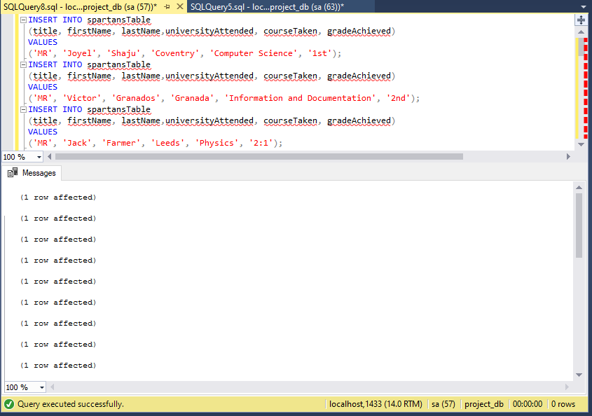

## Exercise 3 – Northwind Data Analysis linked to Excel (30 marks)

Write SQL statements to extract the data required for the following charts (create these in Excel):

3.1 List all Employees from the Employees table and who they report to. No Excel required. (5 Marks)

SELECT

CONCAT(e.Title , ': ' , e.FirstName , ' ' , e.LastName) AS "Employee",

CONCAT(m.Title , ': ' , m.FirstName , ' ' , m.LastName) AS "Employee Reports To"

FROM Employees e

LEFT JOIN Employees m ON m.EmployeeID = e.ReportsTo

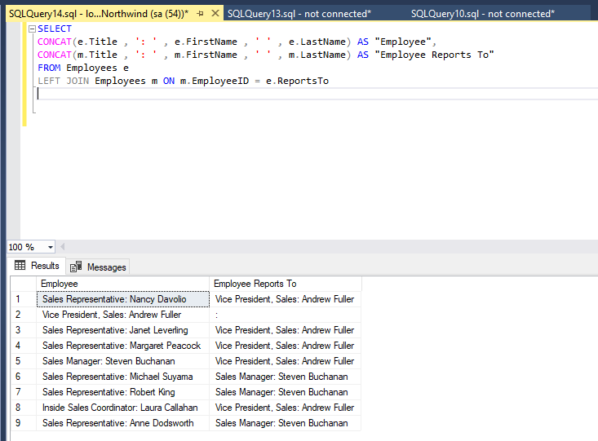

3.2 List all Suppliers with total sales over $10,000 in the Order Details table. Include the Company Name from the Suppliers Table and present as a bar chart as below: (5 Marks)

SELECT

s.CompanyName AS "Company Name",

SUM((od.UnitPrice*od.Quantity)*(1-od.discount)) AS "Sales Total"

FROM Suppliers AS "s"

INNER JOIN Products AS "p" ON s.SupplierID = p.SupplierID

INNER JOIN [Order Details] AS "od" ON od.ProductID = p.ProductID

GROUP BY s.CompanyName

HAVING SUM((od.UnitPrice*od.Quantity)*(1-od.discount)) > 10000

ORDER BY "Sales Total" DESC;

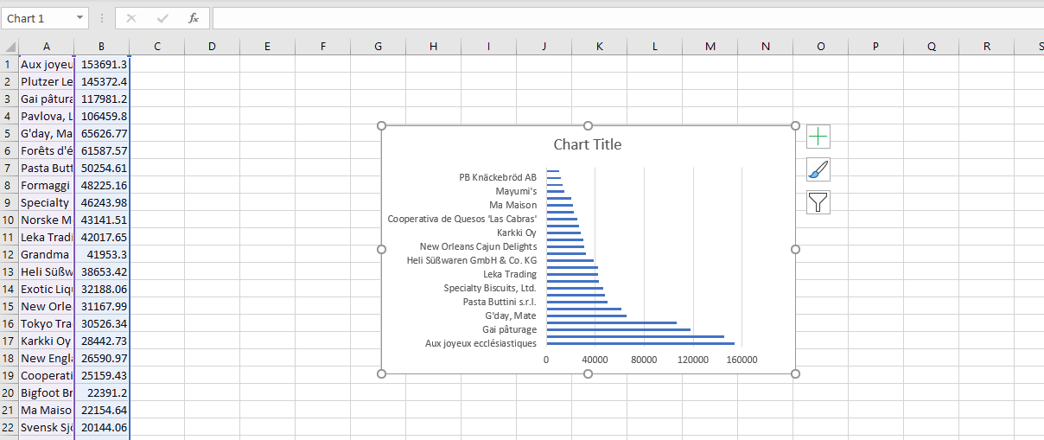

3.3 List the Top 10 Customers YTD for the latest year in the Orders file. Based on total value of orders shipped. No Excel required. (10 Marks)

SELECT TOP 10

CustomerID AS "Customer",

SUM(UnitPrice * Quantity * (1 - Discount)) AS "Total Sales"

FROM Orders AS "o"

JOIN [Order Details] AS "od"

ON o.OrderID = od.OrderID

GROUP BY CustomerID, OrderDate

HAVING YEAR(OrderDate) = 1998

ORDER BY "Total Sales" DESC;

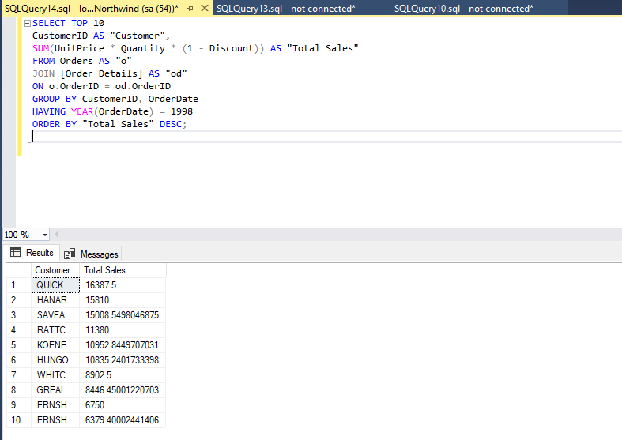

3.4 Plot the Average Ship Time by month for all data in the Orders Table using a line chart as below. (10 Marks)

SELECT

CONCAT(MONTH(OrderDate), ' ', YEAR(OrderDate)) AS "Order Date",

AVG(DATEDIFF(DAY, OrderDate, ShippedDate)) AS "Average Shipping Time"

FROM Orders

GROUP BY CONCAT(MONTH(OrderDate), ' ', YEAR(OrderDate));

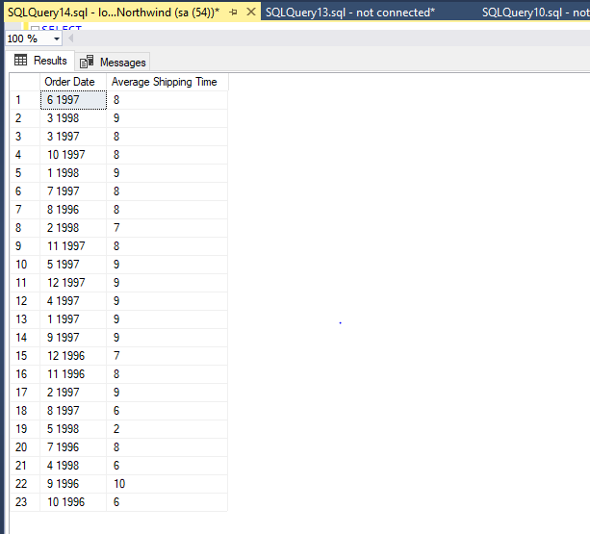

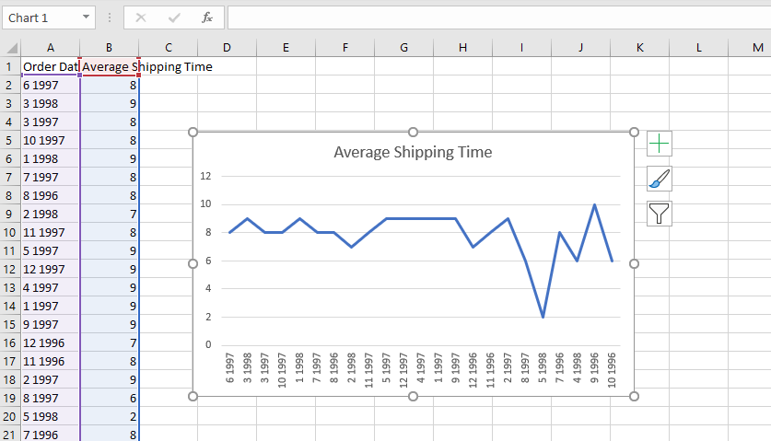

## Standards (10 marks)

Remember to apply all the following standards:

* Use consistent capitalisation and indentation of SQL Statements
* Use concise and consistent table alias names
* Use column aliases to ensure tidy column headings (spaces and consistent capitalisation)
* Concatenate any closely related columns e.g. First Name and Last Name or Address and City etc
* Put comments throughout